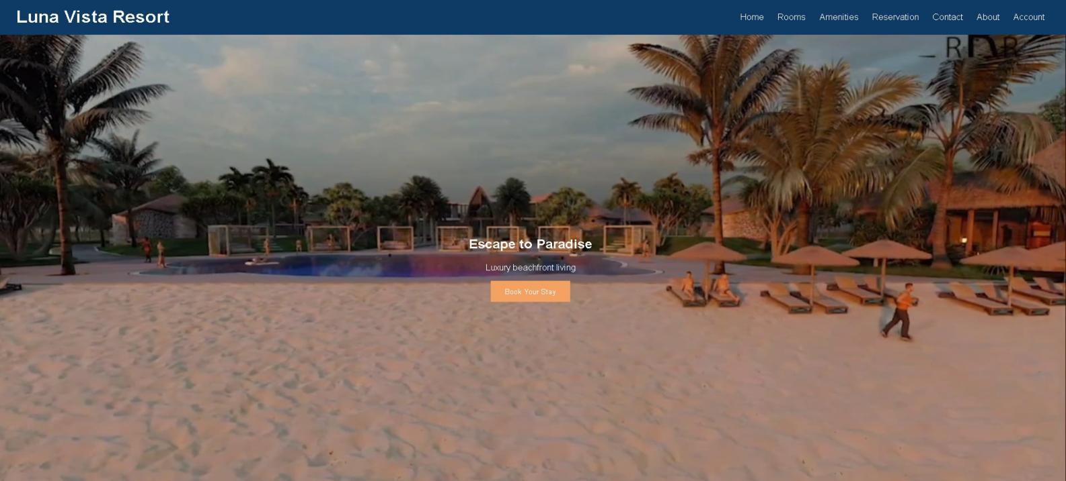

Luna Vista Resort
Home Rooms Amenities Reservation Contact About Account
Rooms
- showcases the different accommodations available at Luna Vista Resort. Each room type is displayed using a card-style layout that includes an image, the room name, a short description, and key features such as bed type, room capacity, and amenities.
Reservation
- allows users to book their stay at Luna Vista Resort through an easy-to-use booking form.
Amenities
- highlights the facilities and services available to guests during their stay at Luna Vista Resort.

